Grace’s Go Kart Dash Group Report

# Game Functionality

The aim of the game is help Grace to get to Luton on her kart as fast as you can by playing all the levels and answering questions to get upgrades. Unfortunately due to the lack of time, we could not implement the upgrades function.

When the game starts it shows a screen like the one above:

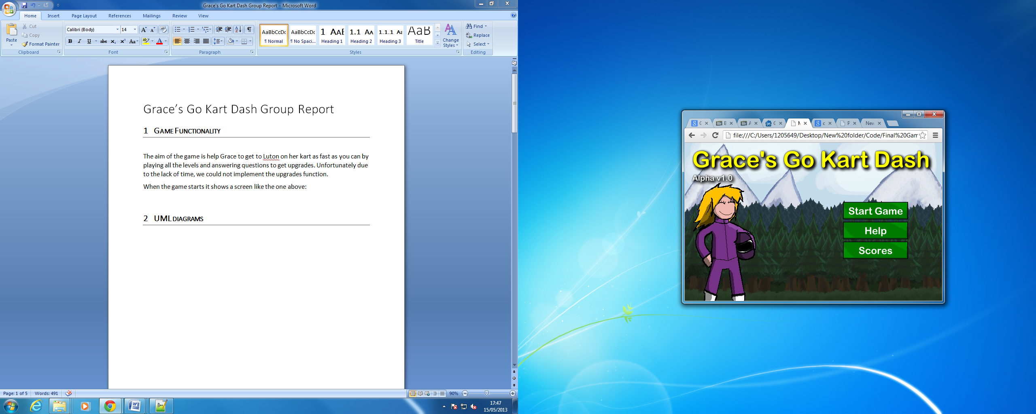

* Start Game button will start the intro level, which will show a little intro with grace on a kart without engine.
* Help Button, which will show the help screen.
* Scores Button will show a scoreboard window.

To manage the physic of the game, we used the library of Corey O’Neil, we could have use a physic engine like Box2D, which is a powerful tool for making physic base games but for our purpose, the pixel collision approach was enough.

# UML diagrams

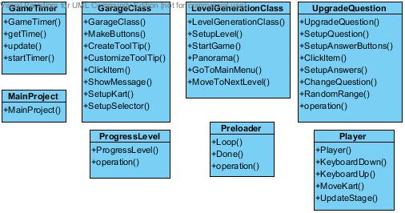

# Screen shot

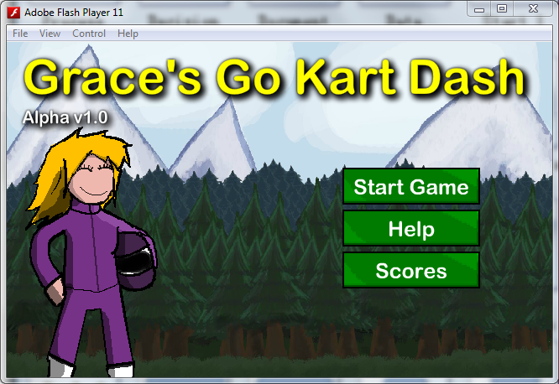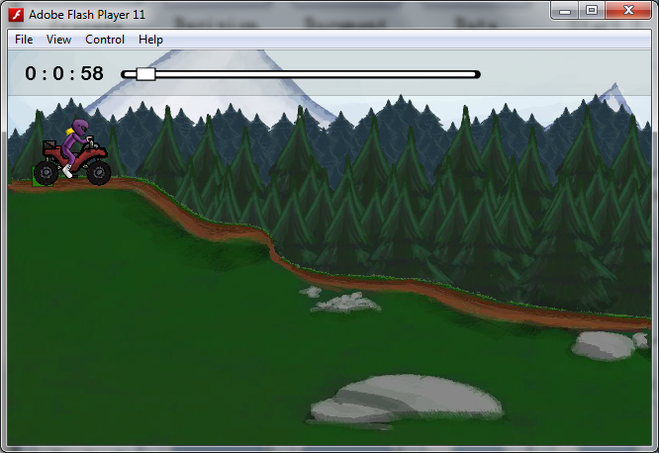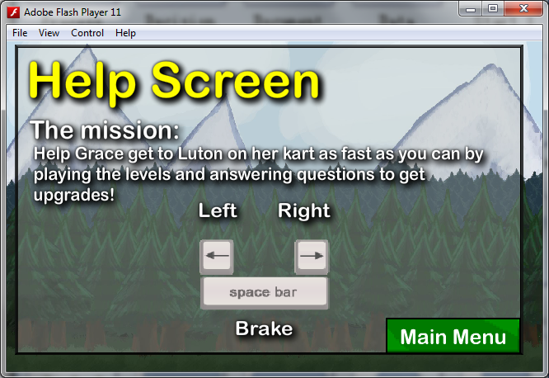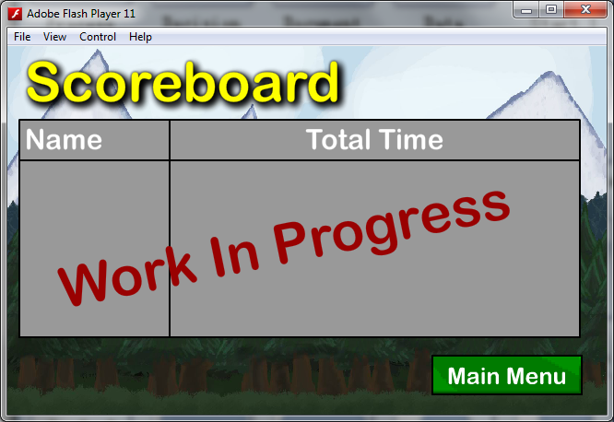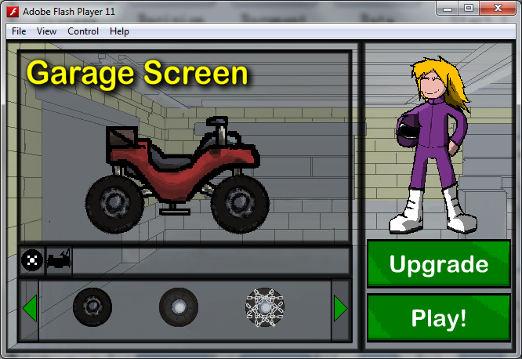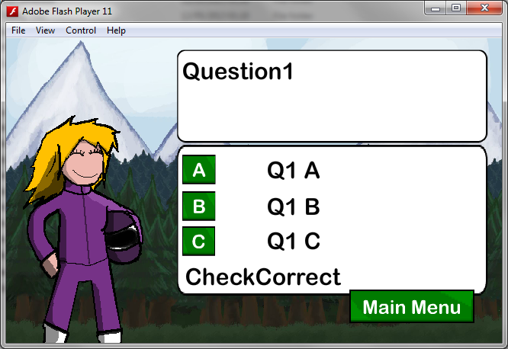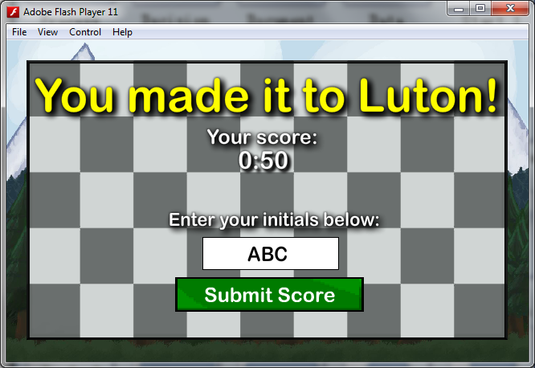

# Screenshots and testing

|  |  |  |  |  |  |
| --- | --- | --- | --- | --- | --- |
| Test No. | Purpose | Description | Test Data | Expected Result | Pass or Fail (how did it fail) |
| 1.0 | Check that the start button takes the user to the intro level.  (Main Menu) | When the user click on the Start Game button, the intro Level will start. | Click button | Play the intro level swf file | Pass |
| 1.1 | Check that the help button takes the user to the help screen.  (Main Menu) | When the user clicks on the Help button, it will show the help screen. | Click button | Show the Help screen | Pass |
| 1.2 | Check that the Scores button takes the user to the help screen.  (Main Menu) | When the user clicks on the Scores button, it will show the scoreboard. | Click button | Show the Scoreboard screen | Pass |
| 1.3 | Check that the question screen pop out from the intro level. | While the intro level is playing the question screen is meant to pop out. | Wait | Show the question screen | Pass |
| 1.4 | Check that the help screen pop out after the intro level. | After grace has pushed the kart to the garage, a help screen should pop up before playing level 1 | Wait | Show the help screen | Pass |
| 1.5 | Check that the timer is counting up. | After a Level in loaded, a timer should start counting from 0 : 00 | wait | Start counting from 0 : 00 | Pass |
| 1.6 | Check that the garage screen is loaded after finish the level. | When the player gets to the garage, it will stop the timer and load the garage screen. | Reach the garage | Show the garage screen | pass |
| 1.7 | Check if the player can customize the kart. | Be able to change the component of the kart (wheel and body). | Click Button | Change the component of the kart. | Pass |
| 1.8 | Preview the next level from the garage. | Click on grace to preview the next level. | Click Event | Plays a preview of the next level. | Pass for all the level, expect for the last one, because we haven’t implement the swf file. |
| 1.9 | Check if the next level can be loaded | Click on Play button from the garage screen | Click Buttton | Play the next level | Pass |
| 2.0 | Show total time, after finish all the level | After finish the level, the score screen is meant show. | Finish all the levels | Shows scores screen | Pass |
| 2.1 | Click on submit score from the score screen | Show s the scoreboard screen after clicking on Submit Score button | Click button | Shows the scoreboard screen |  |

# Full Code commenting

See source files